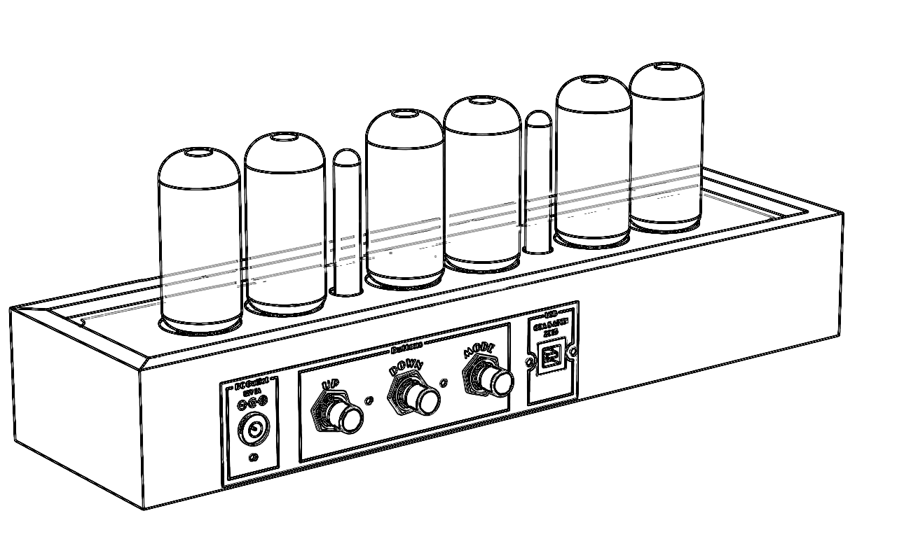

Divergence Meter

Nixie Clock

Operating instruction

2036

Release 1.4

Gra & AFCH

**GENERAL GUIDE**

1. Press “Mode” to change from mode to mode. Each mode is explained in detail on the following pages.

Date

Time

Alarm

Blanking

Display Format

**TIMEKEEPING MODE**

**To set the digital time**

1. Hold down “Mode” while in the Timekeeping Mode until the hours digits start to flash. The hours flash because they *are selected*.
2. Press “Mode” to change the selection in the following sequence:

Minutes

Timekeeping

Seconds

Hours

* Once you reach the Timekeeping display, you have to hold down “Mode” again to display flashing hours.
* While the digits are selected (flashing), hold down “Mode” to return in Timekeeping Mode without saving.

1. While any digits are selected, press “Up” to increase the number, or “Down” to decrease the number. Holding down “Up” or “Down” changes the current selection at high speed.
2. After you set the time, press “Mode” to select the Timekeeping Mode.

* If you do not operate any button for a few minutes while selection is flashing, the flashing stops and the clock goes back to the Timekeeping Mode automatically.

**DATE MODE**

**To set the date**

1. Hold down “Mode” while in the Date Mode until the days digits start to flash. The days digits flash because they *are selected.*
2. Press “Mode” to change selection in following sequence:

Years

Months

Days

Date Mode

* Once you reach the Date Mode, you have to hold down “Mode” again to display the flashing days.
* While the digits are selected (flashing), hold down “Mode” to return in Timekeeping Mode without saving.

1. While any digits are selected, press “Up” to increase the number, or “Down” to decrease the number. Holding down “Up” or “Down” changes the current selection at high speed.
2. After you set the date, press “Mode” to select the Date Mode.

* If you do not operate ant button for a few minutes while a selection is flashing, the flashing stops and clock goes back to the Date Mode automatically.
* The clock does make validation for correct date. So clock not to return to Date Mode if date is incorrect.

**ALARM MODE**

When the Daily Alarm Function is switched on, the alarm sounds at the preset time each day. Press any button to stop the alarm after it starts to sound.

**To set the alarm time**

1. Hold down “Mode” while in Alarm Mode until the hour digits start to flash. The hour digits flash because they are *selected*.
2. Press “Mode” to change selection in the following *sequence*.

Seconds

Minutes

Daily alarm on/off

Timekeeping

Hour

* Press “Up” or “Down” buttons to increase or decrease selected digits. Holding down buttons changes the selections at high speed.
* Daily alarm on/off mode is represented by upper separate dots, press “Up” or “Down” to enable or disable daily alarm.
* Entering in Alarm Mode always switch daily alarm on.
* If you do not operate any buttons a few minutes while a selection is flashing, the flashing stops and the clock goes to the Timekeeping Mode.

**Display Format Mode**

**To change display format**

1. Hold down “Mode” while in Display Format mode until the Leading Zero digits start to flash.
2. Press “Mode” to change the selection in the following sequence:

Display Format

Date Format

12/24 Hour

Leading Zero

1. In Leading Zero, enter 0 for no leading zero, 1 for a leading zero.
2. In 12/24 hour enter 12 for 12 hour mode or 24 for 24 hour mode.
3. In Date Format, enter 0 for DD/MM/YY, 1 for MM/DD/YY or 2 for YY/MM/DD
4. After you set date format press “Mode” button to enter Blanking Mode.

**Blanking Mode**

1. Hold down “Mode” while in Blanking Mode to change when the display is turned on or off.
2. Press “Mode” to change the selection in the following sequence:

Display On

Display Off

Blanking

1. Use the up/down buttons to change the hour that the display is turned on and turned off.
2. If you set the display on to be the same time as the display off the display will always be on.

* If you do not operate any buttons a few minutes while a selection is flashing, the flashing stops and the clock goes to the Timekeeping Mode

**LED Backlight**

**To disable LED backlight**

1. Hold down “Down” until the LED backlight turns off.

**To enable LED backlight**

1. Hold down “Up” until the LED backlight turns off.

**POWER ON SELF TEST**

Immediately after a clock is powered on Self-Test is starting in the following sequence:

1. Red LEDs on.
2. Green LEDs on.
3. Blue LEDs on.
4. Tubes test which display all digits from 0 to 9 on all tubes simultaneously.
5. Input voltage test.
6. Firmware version.
7. Sound test.